* To select just names from the database you must use the select statement; then pick the column and table you want to retrieve and select the columns from. The select statement is used to retrieve any data from the database.

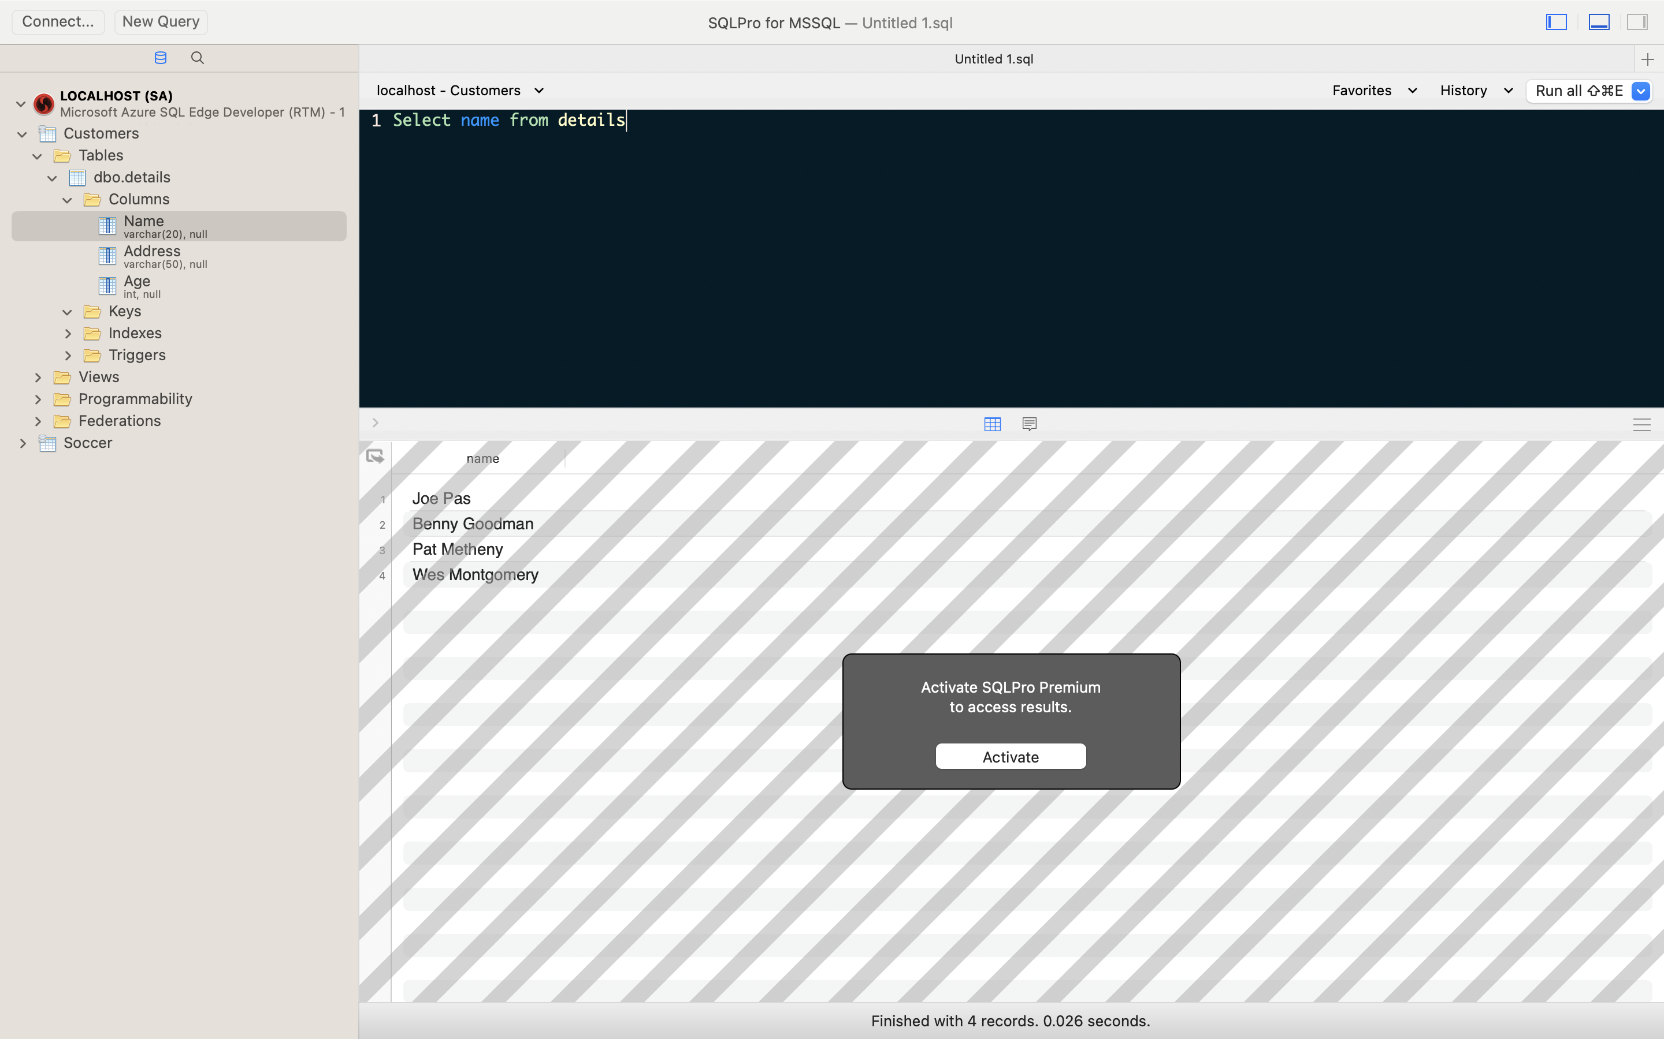

* To select everyone over 25 from the database you must use the where clause. The where clause is used when you want to retrieve specific items of data from the table identified from the select clause 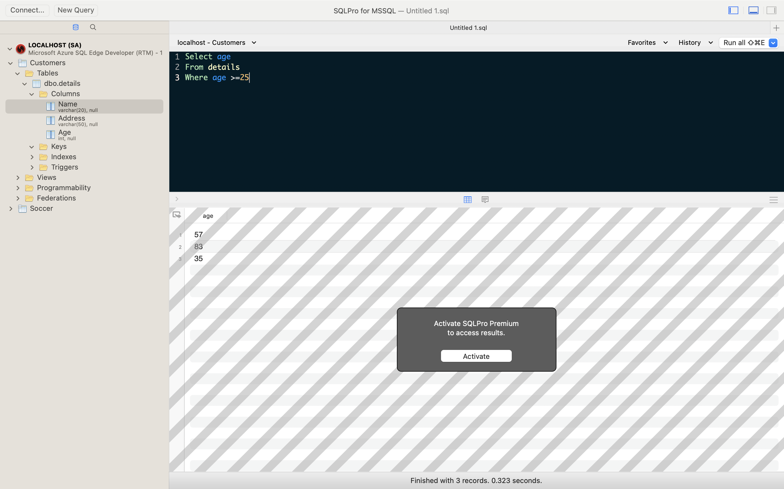
* To change the name “Joe Pas” to “Django Reinhardt” you must use the update table statement, and then type the column name and value you want to change to. You must use the where clause to highlight the value you want to change from. Which limits the rows which can be changed 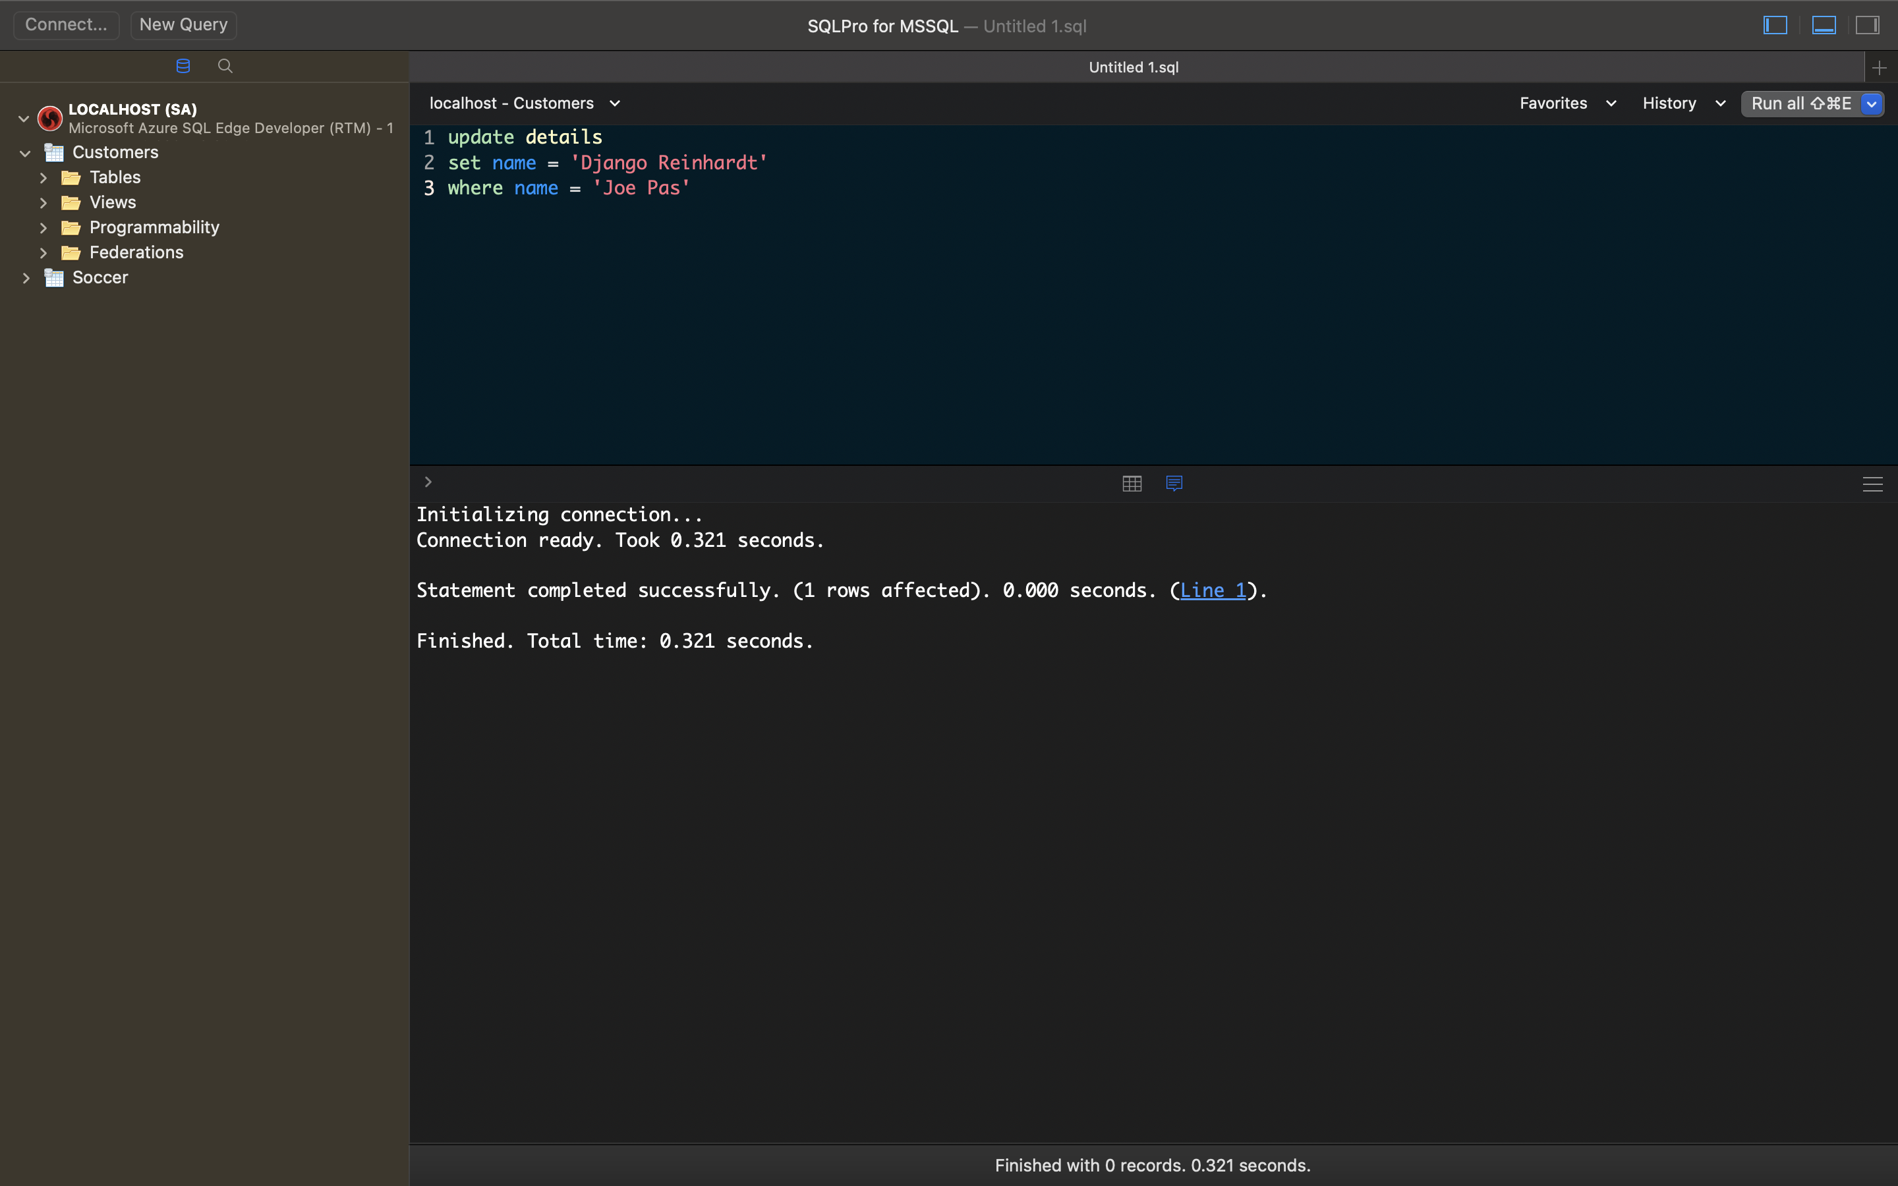
* To insert a record into the table you should use the insert table command and then type the values you would like to add.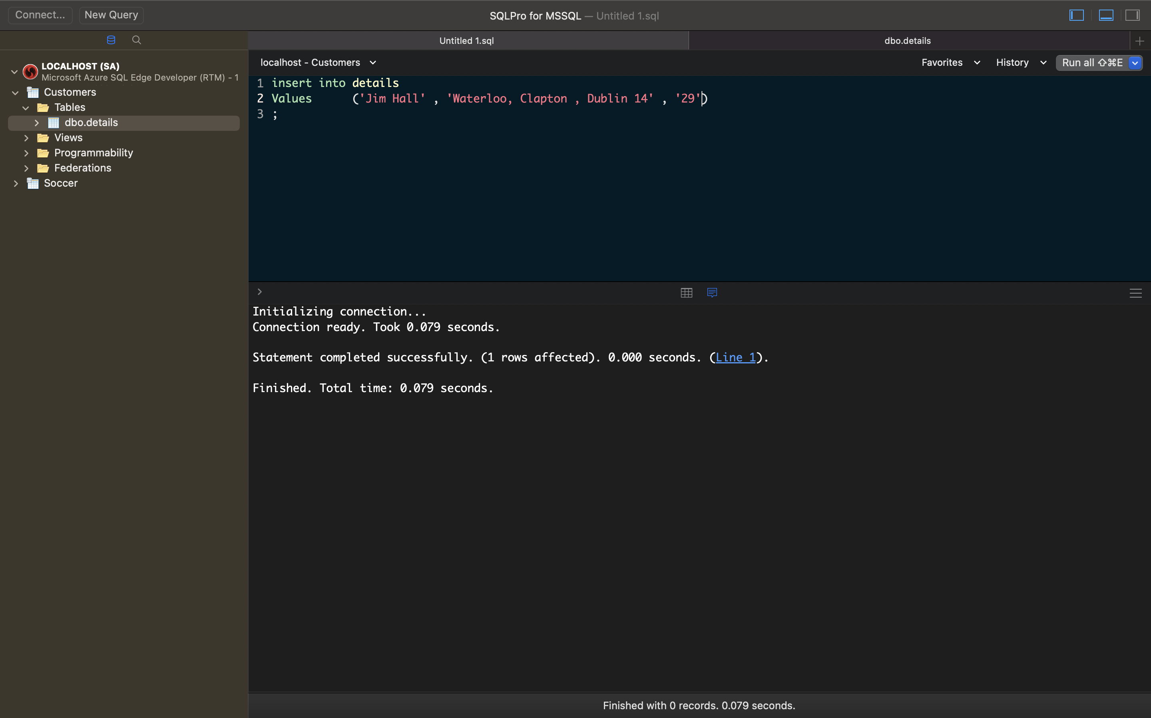
* To remove a row from the table you should use the delete statement and where the record is you want to remove

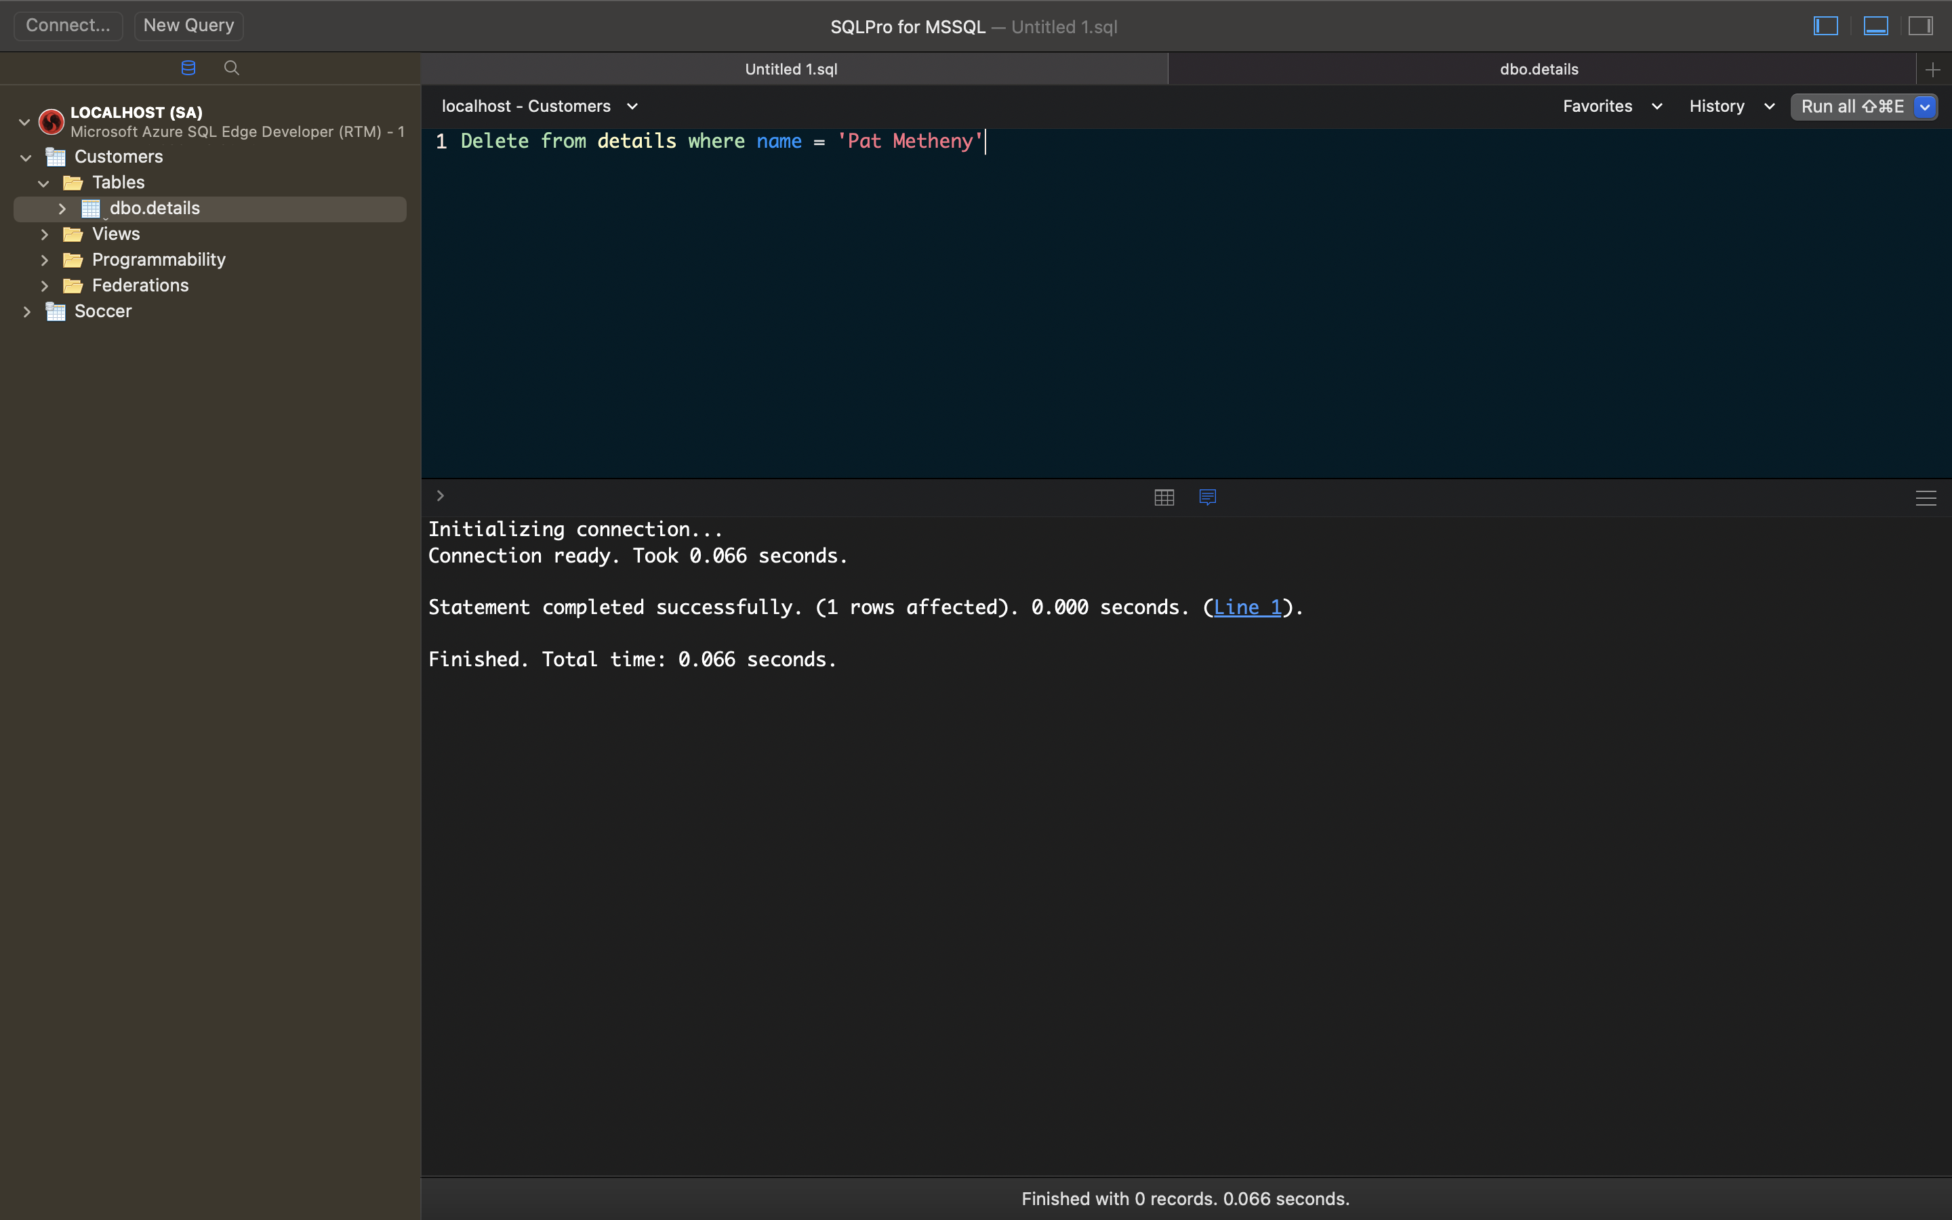

* To remove this table from the database you should use the drop table command